1. Install CMake.
2. Run CMake and create glfw project, which is a dependency of UniEngine.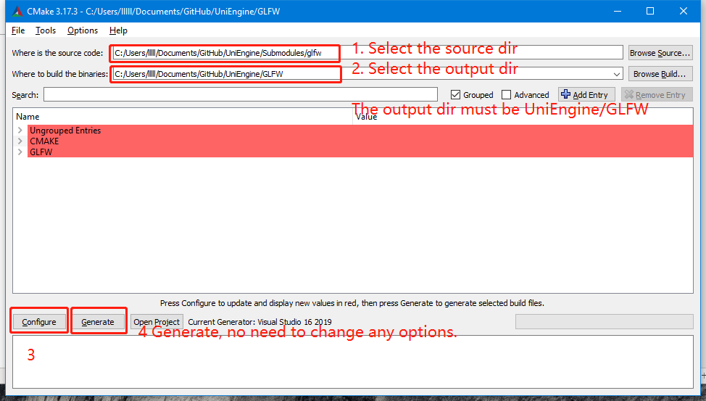
3. After step 2, you should see files in UniEngine/GLFW.
4. Open the solution GLFW in UniEngine/GLFW. Rebuild the solution for Debug-x64 and Release-x64.
5. Open UniEngine.sln, right click the glfw project, select reload project.
6. Open UniEngine.sln
7. 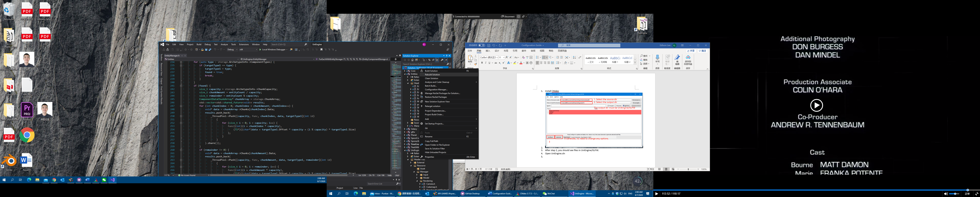 Rebuild solution.
8. If all succeed, run project with: 
9. You can run project in Release mode instead of Debug mode as chosen above. It will give you a big performance boost while you can’t set breakpoint sometimes.
10. The runnable projects are: Galaxy, Planet, SpaceColonizationTree, SponzaTest, TreeCreator.
11. If you want to run another project, right click and select “Set as startup project.”